
National University of Computer & Emerging Sciences, Karachi
FALL-2021 CS-Department
Final Exam
4th of Jan 2021, 06:00 pm – 09:00 pm
Course Code: CS3005 | Course Name: Theory of Automata
Instructor Name: Mr. Musawar Ali
Student Roll No:

Instructions:
- Return the question paper.
- Attempting of the question in the given order is highly encouraged.
- Read each question completely before answering it. There are 6 questions on 3 pages.
- In case of any ambiguity, you may make assumption. But your assumption should not contradict any statement in the question paper.

Time: 180 minutes. Max Marks: 160 points

Question 1: Regular expression & Properties (5+5) Points
a) Give the equivalent REs for the following regular expressions other than the given one.
1. (bbb)* a (bb)*+ (bb)* a (bbb)*
2. a*(a+b)*a* + b*(a+b)*bb*

b) Let L₄ = L₁ ∩ L₂. If L₁ is context free and L₂ is context, then L₄ is not context free. Discuss with an example.

Question 2: Finite Automata (10+10+10) Points

- Find out the union and intersection using Kleen’s Theorem of the following FAs.

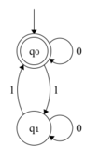 | 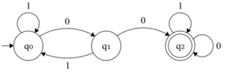

b) Convert the following NFA to equivalent DFA.
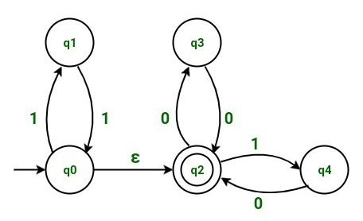
c) Minimize the following DFA using the method of your own choice.
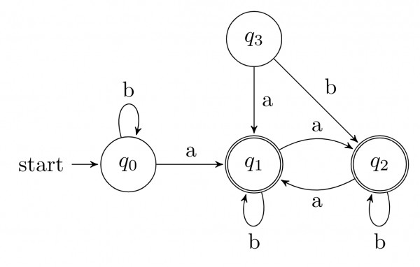
Question 3 (a): CFG (5+5+5+5) Points
Construct a CFG which generates the following languages:
- L4 = { 0^{i}1^{j}2^{k}| I >=3,j,k>=0}
- L1 ={ 0^{i}1^{j}2^{k}|j <=i }
- L2 ={ 0^{i}1^{j}2^{k}|j <=k }
- Find L3 = L1∪L2
Question 3 (b): CFG (10) Points
Check the ambiguity in the following grammar with the help of at least 3 derivation trees.
E -> I
E -> E + E
E -> E * E
E -> (E)
I -> ε | 0 | 1 | 2| 3 | 4 | 5 | 6 | 7 | 8 | 9

Question 4: CNF (10+10) Points
Consider the following CFG for non-empty language:
S→ASA│BSB│AA│BB│A│B
S→ASA│BSB│AA│BB│a│b
A→CA│DB│AA│BB│a│b
B → ab |AS | ε

- Simplify showing each steps clearly.
- Convert the above CFG into CNF.

Question 5: P.D.A. (10+10) Points
- Identify language of given CFG, construct a P.D.A. and trace the input string ------ using stack :
S→ 0S11| 0S111 |^
Trace the input string "001111" using stack. Is the string accepted by the grammar?

- Construct a PDA for language L ={ a^{n}b^{m}c^{k}d^{l}|n+m = (2k+2l)/2 ≥0}. Trace the input string, which belong to language (length of string should be at least 6) using stack.

Question 6: Turing Machine. (15+15+5) Points
a) Design Turing machine for language:
- L = {ab, ba, aa, bb)}
- L = { abc (a + b)*cba}
- Elaborate the concept of recursively enumerable languages by drawing Chomsky’s hierarchy.
b) State the various states of the Turing machine and explain all the states by giving examples.
(15) Points

BEST OF LUCK!

